Ji X et al. (2024) THE IMPACT OF COMPREHENSIVE NURSING ON THE EFFICACY OF PNEUMATIC VENTILATOR TRANSPORT IN CRITICALLY ILL ATHLETES: A META-ANALYSIS. Revista Internacional de Medicina y Ciencias de la Actividad Física y el Deporte vol. 24 (95) pp. 468-481
DOI: https://doi.org/10.15366/rimcafd2024.95.029
ORIGINAL
THE IMPACT OF COMPREHENSIVE NURSING ON THE EFFICACY OF PNEUMATIC VENTILATOR TRANSPORT IN CRITICALLY ILL ATHLETES: A META-ANALYSIS
Xiaodong Ji*, Dan Ju, Chuan Li
Department of Respiratory and Critical Care Medicine, West China Hospital of Sichuan University, Chengdu 610041, China
E-mail: jixiaodongaa@163.com
Recibido 22 de Junio de 2023 Received June 22, 2023
Aceptado 22 de Febrero de 2024 Accepted February 22, 2024
ABSTRACT
Emergency critical illness is a common disease in the emergency department. However, whether it contributes to the effects of pneumatic ventilator on emergency critical remains unknown. Thus, the present study investigated the transport effect of pneumatic ventilator in emergency critical athletic patients using Meta-analysis. A comprehensive literature search was conducted in platforms of PubMed, Embase, Cochrane Library, and Web of Science. The basic features of 5 studies was evaluated using The Cochrane Collaboration's tool for assessing risk of bias. Pneumatic ventilator increased Vt in emergency critical athletic patients (Mean difference = 0.66, 95%CI: 0.38-0.93, p<0.00001). Pneumatic ventilator also increased PEEP in emergency critical patients (Mean difference = 0.29, 95%CI: 0.13-0.45, p=0.0004). Pneumatic ventilator enhanced Ti in emergency critical athletic patients (Mean difference = 0.24, 95%CI: 0.19-0.30, p<0.00001). pneumatic ventilator not affected Ti/Ttot in emergency critical patients (Mean difference = 0.08, 95%CI: -0.18-0.35, p=0.53). Pneumatic ventilator reduced RR in emergency critical athletic patients (Mean difference = -1.65, 95%CI: -2.52--.077, p<0.0002). Pneumatic ventilator increased MAP in emergency critical athletic patients (Mean difference = 5.90, 95%CI: 1.99-9.82, p=0.003). These data demonstrate that The effect of comprehensive nursing for pneumatic ventilator could improve emergency critical athletic patients.
KEYWORDS: Meta-analysis; Pneumatic ventilator; Comprehensive nursing; emergency critical
1. INTRODUCTION
The in-hospital transfer and handover of emergency critical athletic patients is the transfer and handover of athletic patients to other departments in the hospital (including ward (including ICU), operating room, etc.) due to the needs of diagnosis and treatment after the initial rescue treatment in the emergency department (Brotherton et al., 2019). Although this process only takes a few minutes to ten minutes, There are many high-risk factors such as endangering athletic patients' lives and information errors in hospital transfer (Hodges & Larra, 2021). It has been reported in the literature that up to 71% of the transit patients had slight or even serious complications during transit or examination, and the mortality rate of the athletic patients was 9.6% higher than that of the normal (Bernfeld, 2020).
For the athletic patients in the emergency department, they often have the characteristics of urgency, danger and severity. If the first-aid measures are not taken for the athletic patients in time, the best chance to save lives may be missed (Murray et al., 2021). In addition, the athletic patients in the emergency department have the characteristics of diverse disease types, serious illness, complexity and variability, and poor work predictability (Reynolds et al., 2020). A little negligence will lead to hidden dangers in medical treatment and nursing, and even cause dissatisfaction of athletic patients and their families, resulting in medical disputes (Noble, Owens, Thulien, & Suleiman, 2022). The traditional first aid mode cannot meet the needs of the new era (Swain O'Fallon, 2021). Therefore, it is necessary to establish a new first aid nursing mode that adapts to social development (Tran & Witek, 2021). The humanized whole process nursing mode has become one of the most important explorations in recent years, and has achieved very good results (Meuli et al., 2021).
Comprehensive nursing intervention is a whole process high-quality nursing service aimed at improving the therapeutic nursing effect (Mikkelsen et al., 2020). The comprehensive nursing intervention measures were applied to put forward the nursing safety problems existing in the hospital transfer of emergency athletic patients, and the improvement was made to make the nursing work more perfect (Stollings et al., 2021). The implementation of comprehensive nursing intervention measures for emergency critical athletic patients can reduce the accidents that may occur in the process of transport, increase the satisfaction of athletic patients with the quality of care, improve the quality of life of patients, and promote the good relationship between nurses and athletic patients (Haines, Quasim, & McPeake, 2018). It is worth popularizing in the clinic (Tume et al., 2015).The emergency department is a special department of the hospital. Most of its service objects are critically ill athletic patients (Kearl & Hooper, 1993). After early treatment, they usually need to be transferred to other departments in the hospital for further treatment. During this period, the athletic patient's condition is prone to sudden change, and a slight carelessness will lead to deterioration of the condition, thus causing medical disputes (Knorr et al., 2020). Some studies have shown that critical athletic patients in the emergency department are often accompanied by severe hypoxemia (Al-Dorzi et al., 2022; Ige, Adetunla, Amudipe, Adeoye, & Glucksberg, 2022). When they are transported in the hospital, sufficient oxygen supply is given to ensure the stability of respiratory circulation, which is of great significance to prevent asphyxia and death during transport and improve the success rate of transport (Langer et al., 2019). Therefore, it is necessary to strengthen the management of respiratory tract of critically ill athletic patients in emergency department. The pneumatic ventilator is the main equipment for respiratory support (Marjanovic et al., 2017). The main machine is simple in structure and small in design. It is driven by oxygen pressure during use. It does not need external power supply and is easy to move (Savary et al., 2020). It is often used in out of hospital emergency, in hospital transport and family treatment (Al-Dorzi et al., 2022). However, whether it contributes to the effects of pneumatic ventilator on emergency critical remains unknown. Thus, the present study investigated the transport effect of pneumatic ventilator in emergency critical athletic patients.
2. Materials and Methods
2.1 Literature search
The experiment was searched from PubMed, Embase and Web of Science, and last search was performed on August 2022. The MeSH terms and free words adopted were as follows: “comprehensive nursing”, “pneumatic ventilator”, “Care”, “emergency critical”, “their combinations”. The reference lists of previous relevant reviews were manually checked to find additional publications of interest. The language of publications was
2.2 Inclusion and exclusion criteria
The following inclusion criteria were used to select eligible studies: (i) the diagnosis of emergency critical was pathologically confirmed; (ii) if more than one articles from one athletic patient's cohort were identified, the most complete one was selected. The exclusion criteria were: (i) abstract, review, case report or comment letter; (ii) animal studies; (iii) duplicate publications; (iv) published not in English.
2.3 Data extraction and Statistical analysis
Two independent reviewers using a standardized form extracted relevant data from eligible studies as literature (Pu, Wang, Xie, Wang, & Hao, 2017). Data were analyzed by Review Manager 5.3 as literature (Pu et al., 2017). Heterogeneity among studies was examined using Chi-square based Q test in which I2 indicates level of heterogeneity. I2<50% or Pheterogeneity>0.1 were represented low heterogeneity. P<0.05 was considered as statistically significant.
3. Results
3.1 Sketch and characteristics of included studies
This experiment identified using a meta-analysis through systematic literature searching. Then, 122 literatures were evaluated and the literature selection process was shown in Figure 1. The basic features of 5 studies (Kuo et al., 2016; Liu et al., 2015; Liu et al., 2021; Moerer et al., 2008; Savary et al., 2020) (2015 to 2021) were shown in Table 1 and the sample size ranged from 16 to 40, and total sample size was 157. The quality of literatures was evaluated using The Cochrane Collaboration's tool for assessing risk of bias (Fig 2A-2B). The numerous numbers of studies were randomized, correct allocation concealment strategies, reported incomplete outcome data and double-blind (Fig 2A-2B).
Table 1: Basic characteristics of included studies.
STUDY YEAR | COUNTRY | ETHNICITY | CASES | GROUP
KUO 2016 | China | East Asia | 33 | 19/14
LIU 2015 | China | East Asia | 24 | 12/12
LIU 2021 | China | East Asia | 16 | 8/8
MOERER 2008 | Canada | North American population | 40 | 20/20
SAVARY 2020 | France | Caucasian population | 20 | 10/10
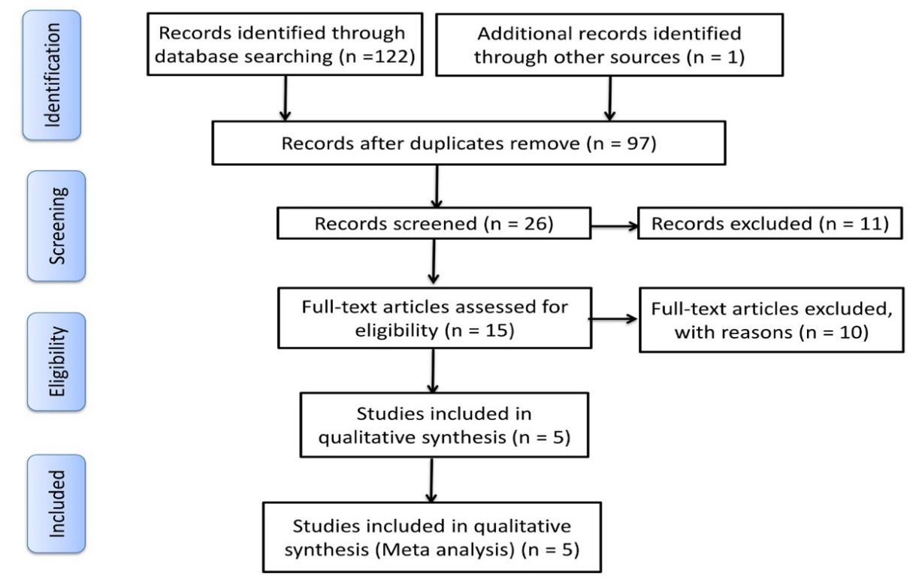
Figure 1: Sketch of included studies
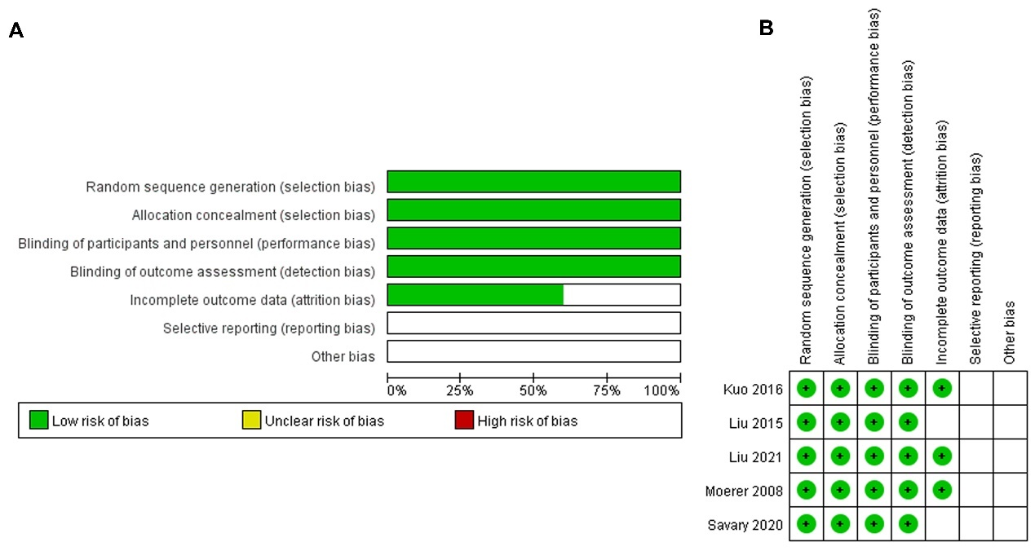
Figure 2: Characteristics of included studies
Risk of bias summary (A), Risk of bias graph (B)
3.2 The transport effect of pneumatic ventilator on Tidal volume (Vt) and PEEP (positive end expiratory pressure) in emergency critical athletic patients
The study analyzed the transport effect of pneumatic ventilator on Vt and PEEP in emergency critical athletic patients. Pneumatic ventilator increased Vt in emergency critical athletic patients (Mean difference = 0.66, 95%CI: 0.38-0.93, p<0.00001, Figure 3A). Pneumatic ventilator also increased PEEP in emergency critical athletic patients (Mean difference = 0.29, 95%CI: 0.13-0.45, p=0.0004, Figure 3B). So, these results showed that pneumatic ventilator recovered Vt and PEEP in emergency critical athletic patients.
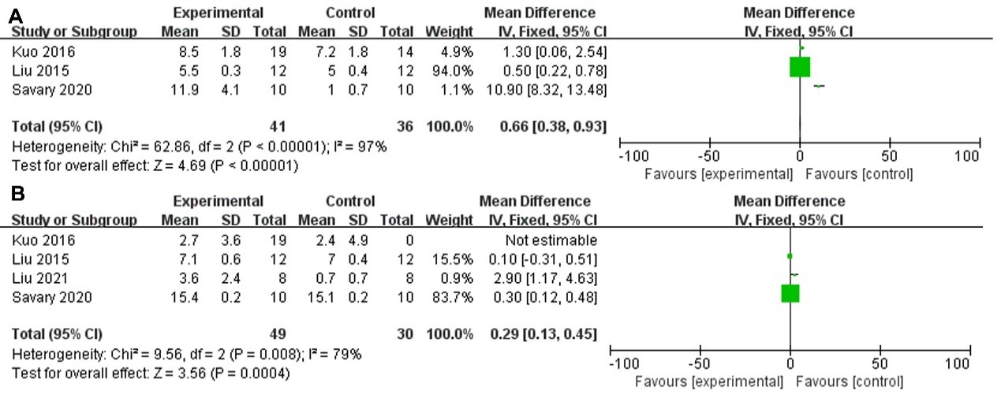
Figure 3: The transport effect of pneumatic ventilator on Tidal volume (Vt) and PEEP (positive end expiratory pressure) in emergency critical patients.
Vt (A) and PEEP (B).
3.3 The transport effect of pneumatic ventilator on neural inspiratory time (Ti) and Ti/Ttot (total neural inspiratory and expiratory time) in emergency critical athletic patients
Next, we explored the transport effect of the pneumatic ventilator on Ti and Ti/Ttot in emergency critical patients. Pneumatic ventilator enhanced Ti in emergency critical athletic patients (Mean difference = 0.24, 95%CI: 0.19-0.30, p<0.00001, Figure 4A).
However, the pneumatic ventilator did not affect Ti/Ttot in emergency critical patients (Mean difference = 0.08, 95% CI: -0.18-0.35, p=0.53, Figure 4B). Thus, these results showed that the pneumatic ventilator recovered Ti in emergency critical athletic patients.
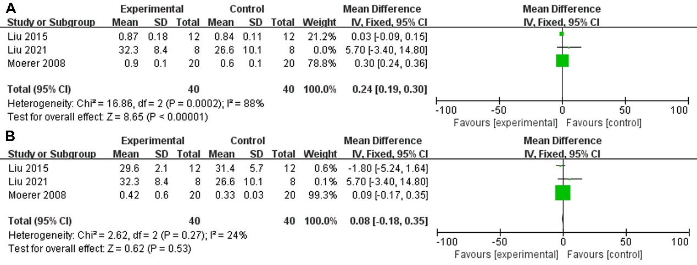
Figure 4: The transport effect of pneumatic ventilator on neural inspiratory time (Ti) and Ti/Ttot (total neural inspiratory and expiratory time) in emergency critical patients.
Ti (A) and Ti/Ttot (B).
3.4 The transport effect of pneumatic ventilator on respiratory rate (RR) and MAP (mean arterial pressure) in emergency critical athletic patients
Lastly, this experiment explored the transport effect of pneumatic ventilator on RR and MAP in critical emergency athletic patients. Pneumatic ventilator reduced RR in emergency critical athletic patients (Mean difference = -1.65, 95%CI: -2.52--.077, p<0.0002, Figure 5A).
The pneumatic ventilator increased MAP in emergency critical patients (Mean difference = 5.90, 95% CI: 1.99-9.82, p=0.003, Figure 5B). Thus, these results showed that the pneumatic ventilator recovered RR and MAP in emergency critical athletic patients.
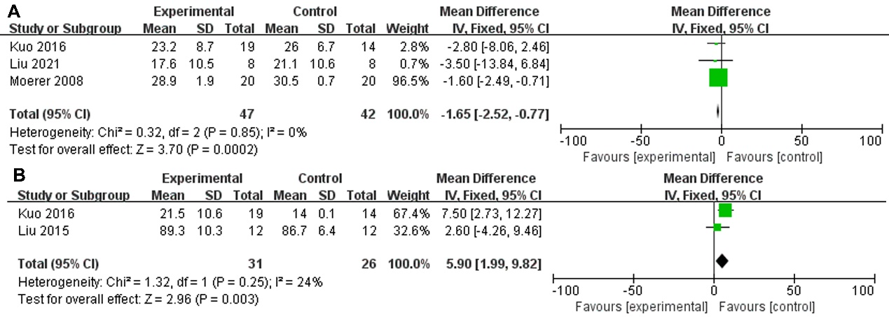
Figure 5: The transport effect of pneumatic ventilator on respiratory rate (RR) and MAP (mean arterial pressure) in emergency critical patients
RR (A) and MAP (B).
3.5 Publication bias
Funnel plots for meta-analysis of major complications and hospital death of athletic patients with emergency critical were shown in Fig 6. The funnel plots for all analysis were symmetric, indicating no obvious publication bias.
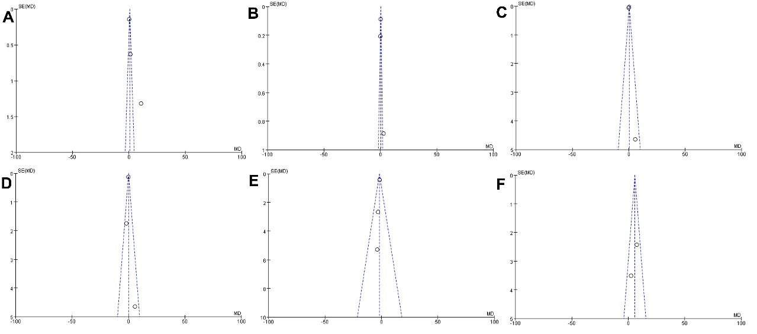
Figure 6: Publication bias
Publication bias for Vt (A), PEEP (B), Ti (C), Ti/Ttot (D), RR (E) and MAP (F).
4. Discussion
Emergency critical illness is a common disease in the emergency department (Fox & Irwin, 2008). Generally, after a series of rescue measures, the athletic patient's condition is effectively controlled and needs to be transferred to the corresponding department for in-depth treatment (Bowles, Lichtenberger, & Lennox, 2007). In the process of transport, the safety of athletic patients’ needs special attention of medical personnel to avoid accidents (Fox & Irwin, 2008). The emergency department is an important department to undertake rescue tasks (Grover, Porter, & Morphet, 2017). The patients admitted by the emergency department are in critical condition and develop rapidly. Therefore, the workload of medical workers is huge. If the patients cannot be treated in time, the life safety of the athletic patients will be endangered (Zimmer, Czarniecki, & Sahm, 2021). In the rescue process, accurate and rapid treatment is important, but whether high quality nursing can be provided will directly affect the success rate of emergency rescue (Reynolds et al., 2020).
The condition of emergency critical athletic patients is complex and changes quickly. The rescue must be carried out in a fast and agile manner (Kuriakose et al., 2022). Any delay will affect the rescue treatment of athletic patients and even endanger their lives. This requires nurses to have skilled nursing operation skills, have solid basic theoretical knowledge, be able to master various first-aid technologies, have strong adaptability and good professional quality (Laubach, Kobbe, & Hutmacher, 2022; Zhang, Wang, Xu, Xie, & Pu, 2021). Having these conditions is conducive to the smooth progress of rescue work, winning valuable rescue time, and also conducive to the tacit understanding between doctors and nurses (Li et al., 2022). It will greatly improve the success rate of rescue of critically ill athletic patients, reduce nursing complications, strengthen communication between doctors and nurses, write the nursing records of critically ill athletic patients in a timely, objective, accurate, true and serious manner, and put an end to medical disputes caused by writing defects (Ganesan, Chawengkijwanich, Gopalakrishnan, & Janjaroen, 2022; Lin et al., 2022). Our results showed that the basic features of 5 studies were included in the meta-analysis.
Most ICU patients are in critical condition, and their immune function is declining. Due to the disease, the application of ventilator, combined with some invasive operations and long-term bed rest, the incidence of lung infection and other related infections in athletic patients has increased significantly. Most of the patients in the ICU are comatose or confused, with an artificial airway inserted, which cannot be directly expressed in words, and the nursing staff cannot be directly informed of any adverse reaction. Therefore, it is difficult to observe the adverse reaction symptoms when some diseases and organ functions are changed. Sometimes, the nursing staff fail to observe the adverse drug reactions in time due to the heavy rescue or treatment workload. During the course of medication, the nursing staff should closely observe the general conditions of the athletic patients. In case of adverse drug reactions, they should assist the doctors in timely emergency treatment while stopping medication.
For athletic patients with critical illness, their psychological state is usually not very ideal, and there will be fear and fear in their hearts, which will have a serious adverse impact on the emergency rescue effect of critical patients (Girard et al., 2018). It is necessary for relevant nursing personnel to conduct targeted psychological counseling in the process of emergency rescue for patients (Girard et al., 2018). The whole process nursing is one of the strict whole process nursing service modes (Gomes, Calanzani, Curiale, McCrone, & Higginson, 2013). Its basic service concept is patient-oriented, patient-centered, and wholeheartedly serving the majority of patients (Gomes et al., 2013). The basic principles of the whole process nursing service are rapid, early warning and early warning, so as to strive for more effective treatment time for emergency rescue athletic patients as much as possible, so as to significantly improve the success rate of emergency rescue for such athletic patients (Haines et al., 2018). The whole course nursing service is a professional and whole course clinical nursing service mode from the time when the athletic patient enters the emergency department of the hospital to the time when the patient is transferred to the Department (Mikkelsen et al., 2020). The implementation of the whole process nursing service can effectively communicate with the patients in the treatment process, and fully establish a good doctor-patient relationship (Jones et al., 2020). It can not only effectively mobilize the enthusiasm of the patients for treatment, but also ensure that the athletic patients can more closely cooperate with the clinicians, put the patients in the first place in the emergency rescue work, and implement all-round nursing intervention for the athletic patients, so as to improve the treatment effect and the athletic patients' satisfaction with the nursing service (Franks et al., 2021).
The emergency department is the front line of the hospital to serve athletic patients. In the process of in-hospital transport, athletic patients have high risk factors (Chiang, Castro, & Sánchez, 2022). Although the time is short, there are hidden dangers (Snooks et al., 2022). Therefore, we should change the traditional concept of in-hospital transport, regularly carry out training, do a good job in risk management, strengthen the service awareness of nursing staff, minimize the risks in the process of transport, do a good job in all aspects, and provide sufficient oxygen to athletic patients, Prevention of nursing disputes (Schell et al., 2022). The present study showed that Pneumatic ventilator increased Vt and PEEP in emergency critical patients.
Closely monitor the athletic patient's vital signs, properly adjust the ventilator, and observe whether the athletic patient has spontaneous breathing, insufficient ventilation or excessive ventilation (Corey et al., 2020). If the patient has sudden dyspnea, irritability and other conditions, the reason should be quickly found and handled in time. If the ventilator confronts, find out the reason (Fang et al., 2020). If the confrontations are serious, consider whether to take off-line, and then go to the simple respirator to supply oxygen until the patient recovers to the original level; Do a good job in the care of athletic patients' tracheal intubation, drainage tube, infusion tube, etc. during the pipe care, the soft packaging plastic bag liquid shall be used for infusion, and the drip rate shall be controlled during the infusion (Mirvakili, Sim, & Langer, 2021). In this study, Pneumatic ventilator enhanced It in emergency critical athletic patients.
In hospital nursing risk management is a long-term work. To strengthen risk management, it is necessary to constantly improve the prevention awareness and ability of nursing staff, establish a sound nursing management mechanism, and ensure the safety of patient transfer (Templier et al., 2007). For patients using non-invasive respirators or patients with high oxygen requirements, oxygen cylinders are used alone to provide oxygen sources (Santivanez et al., 2021; Shavit et al., 2019). For patients with endotracheal intubation, a ventilator combined with an oxygen cylinder was used to maintain respiratory function (Williams, Flory, King, Thornton, & Dingley, 2010). These study suggested that Pneumatic ventilator reduced RR and increased MAP in emergency critical patients. The present study has some limitations. Firstly, five kinds of literature were identified and evaluated in this study. A relatively low number of studies depicted the relationship between pneumatic ventilators and emergency critical. Second, the transport effects of pneumatic ventilator in patients with emergency critical. We will need to develop high-quality, large-scale studies with more complete athletic patient types to verify our results.
Reference
Al-Dorzi, H. M., Al-Dawood, A., Al-Hameed, F. M., Burns, K. E. A., Mehta, S., Jose, J., . . . Arabi, Y. M. (2022). The effect of intermittent pneumatic compression on deep-vein thrombosis and ventilation-free days in critically ill patients with heart failure. Sci Rep, 12(1), 8519. doi:10.1038/s41598-022-12336-9
Bernfeld, J. (2020). Obstacles to timely emergency messaging for acute incidents. J Emerg Manag, 18(5), 425-453. doi:10.5055/jem.2020.0490
Bowles, H., Lichtenberger, M., & Lennox, A. (2007). Emergency and critical care of pet birds. Vet Clin North Am Exot Anim Pract, 10(2), 345-394. doi:10.1016/j.cvex.2007.04.001
Brotherton, B. J., Halestrap, P., Mbugua, E., Gitura, H., Aliba, D., Matson, J. E., & Lee, B. W. (2019). ECCCOing the call for emergency and critical care training in low middle-income countries. Crit Care, 23(1), 244. doi:10.1186/s13054-019-2532-4
Chiang, L. E., Castro, F. A., & Sánchez, T. F. (2022). VEMERS 2.0: Upgrading of an Emergency Use Ventilator from a Single Mandatory Volume Control Mode of Ventilation (VEMERS 1.0) to 8 Modes of Ventilation. J Healthc Eng, 2022, 6965083. doi:10.1155/2022/6965083
Corey, R. M., Widloski, E. M., Null, D., Ricconi, B., Johnson, M. A., White, K. C., . . . Singer, A. C. (2020). Low-Complexity System and Algorithm for an Emergency Ventilator Sensor and Alarm. IEEE Trans Biomed Circuits Syst, 14(5), 1088-1096. doi:10.1109/tbcas.2020.3020702
Fang, Z., Li, A. I., Wang, H., Zhang, R., Mai, X., & Pan, T. (2020). AmbuBox: A Fast-Deployable Low-Cost Ventilator for COVID-19 Emergent Care. SLAS Technol, 25(6), 573-584. doi:10.1177/2472630320953801
Fox, J. C., & Irwin, Z. (2008). Emergency and critical care imaging. Emerg Med Clin North Am, 26(3), 787-812, ix-x. doi:10.1016/j.emc.2008.05.003
Franks, Z. M., Alcock, J. A., Lam, T., Haines, K. J., Arora, N., & Ramanan, M. (2021). Physical Restraints and Post-Traumatic Stress Disorder in Survivors of Critical Illness. A Systematic Review and Meta-analysis. Ann Am Thorac Soc, 18(4), 689-697. doi:10.1513/AnnalsATS.202006-738OC
Ganesan, S., Chawengkijwanich, C., Gopalakrishnan, M., & Janjaroen, D. (2022). Detection methods for sub-nanogram level of emerging pollutants - Per and polyfluoroalkyl substances. Food Chem Toxicol, 113377. doi:10.1016/j.fct.2022.113377
Girard, T. D., Exline, M. C., Carson, S. S., Hough, C. L., Rock, P., Gong, M. N., . . . Ely, E. W. (2018). Haloperidol and Ziprasidone for Treatment of Delirium in Critical Illness. N Engl J Med, 379(26), 2506-2516. doi:10.1056/NEJMoa1808217
Gomes, B., Calanzani, N., Curiale, V., McCrone, P., & Higginson, I. J. (2013). Effectiveness and cost-effectiveness of home palliative care services for adults with advanced illness and their caregivers. Cochrane Database Syst Rev, 2013(6), CD007760. doi:10.1002/14651858.CD007760.pub2
Grover, E., Porter, J. E., & Morphet, J. (2017). An exploration of emergency nurses' perceptions, attitudes and experience of teamwork in the emergency department. Australas Emerg Nurs J, 20(2), 92-97. doi:10.1016/j.aenj.2017.01.003
Haines, K. J., Quasim, T., & McPeake, J. (2018). Family and Support Networks Following Critical Illness. Crit Care Clin, 34(4), 609-623. doi:10.1016/j.ccc.2018.06.008
Hodges, L. R., & Larra, M. D. (2021). Emergency management as a complex adaptive system. J Bus Contin Emer Plan, 14(4), 354-368.
Ige, E. O., Adetunla, A., Amudipe, S. O., Adeoye, A., & Glucksberg, M. (2022). An archetypal model of a breathable air-circuit in an electro-pneumatic ventilator device. Heliyon, 8(5), e09378. doi:10.1016/j.heliyon.2022.e09378
Jones, A. C., Hilton, R., Ely, B., Gororo, L., Danesh, V., Sevin, C. M., . . . Boehm, L. M. (2020). Facilitating Posttraumatic Growth After Critical Illness. Am J Crit Care, 29(6), e108-e115. doi:10.4037/ajcc2020149
Kearl, R. A., & Hooper, R. G. (1993). Massive airway leaks: an analysis of the role of endotracheal tubes. Crit Care Med, 21(4), 518-521.
Knorr, J. M., Sheehan, M. M., Santana, D. C., Samorezov, S., Sammour, I., Deblock, M., . . . Chatburn, R. L. (2020). Design and performance testing of a novel emergency ventilator for in-hospital use. Can J Respir Ther, 56, 42-51. doi:10.29390/cjrt-2020-023
Kuo, N. Y., Tu, M. L., Hung, T. Y., Liu, S. F., Chung, Y. H., Lin, M. C., & Wu, C. C. (2016). A randomized clinical trial of neurally adjusted ventilatory assist versus conventional weaning mode in patients with COPD and prolonged mechanical ventilation. Int J Chron Obstruct Pulmon Dis, 11, 945-951. doi:10.2147/copd.s103213
Kuriakose, A., Nair, B., Abdelgawad, M. A., Adewum, A. T., Soliman, M. E. S., Mathew, B., & Nath, L. R. (2022). Evaluation of the active constituents of Nilavembu Kudineer for viral replication inhibition against SARS-CoV-2: An approach to targeting RNA-dependent RNA polymerase (RdRp). J Food Biochem, e14367. doi:10.1111/jfbc.14367
Langer, T., Baio, S., Chidini, G., Marchesi, T., Grasselli, G., Pesenti, A., & Calderini, E. (2019). Severe diaphragmatic dysfunction with preserved activity of accessory respiratory muscles in a critically ill child: a case report of failure of neurally adjusted ventilatory assist (NAVA) and successful support with pressure support ventilation (PSV). BMC Pediatr, 19(1), 155. doi:10.1186/s12887-019-1527-2
Laubach, M., Kobbe, P., & Hutmacher, D. W. (2022). Biodegradable interbody cages for lumbar spine fusion: Current concepts and future directions. Biomaterials, 121699. doi:10.1016/j.biomaterials.2022.121699
Li, W. F., Alfason, L., Huang, C., Tang, Y., Qiu, L., Miyagishi, M., . . . Kasim, V. (2022). p52-ZER6: a determinant of tumor cell sensitivity to MDM2-p53 binding inhibitors. Acta Pharmacol Sin. doi:10.1038/s41401-022-00973-9
Lin, P. Y., Chen, Y. J., Fan, R. C., Wang, T. Y., Hsu, T. F., Peng, L. N., . . . Hung-Tsang Yen, D. (2022). Cognitive Screening via Comprehensive Geriatric Assessment of Older Patients for the Risk Factors of Hospital Revisit/Readmission after Emergency Department Visit at 3-Month Follow-Up. Dement Geriatr Cogn Disord, 1-12. doi:10.1159/000525786
Liu, L., Xia, F., Yang, Y., Longhini, F., Navalesi, P., Beck, J., . . . Qiu, H. (2015). Neural versus pneumatic control of pressure support in patients with chronic obstructive pulmonary diseases at different levels of positive end expiratory pressure: a physiological study. Crit Care, 19(1), 244. doi:10.1186/s13054-015-0971-0
Liu, L., Xu, X. T., Yu, Y., Sun, Q., Yang, Y., & Qiu, H. B. (2021). Neural control of pressure support ventilation improved patient-ventilator synchrony in patients with different respiratory system mechanical properties: a prospective, crossover trial. Chin Med J (Engl), 134(3), 281-291. doi:10.1097/cm9.0000000000001357
Marjanovic, N., Frasca, D., Asehnoune, K., Paugam, C., Lasocki, S., Ichai, C., . . . Mimoz, O. (2017). Multicentre randomised controlled trial to investigate the usefulness of continuous pneumatic regulation of tracheal cuff pressure for reducing ventilator-associated pneumonia in mechanically ventilated severe trauma patients: the AGATE study protocol. BMJ Open, 7(8), e017003. doi:10.1136/bmjopen-2017-017003
Meuli, L., Zimmermann, A., Menges, A. L., Tissi, M., Becker, S., Albrecht, R., & Pietsch, U. (2021). Helicopter emergency medical service for time critical interfacility transfers of patients with cardiovascular emergencies. Scand J Trauma Resusc Emerg Med, 29(1), 168. doi:10.1186/s13049-021-00981-4
Mikkelsen, M. E., Still, M., Anderson, B. J., Bienvenu, O. J., Brodsky, M. B., Brummel, N., . . . Sevin, C. M. (2020). Society of Critical Care Medicine's International Consensus Conference on Prediction and Identification of Long-Term Impairments After Critical Illness. Crit Care Med, 48(11), 1670-1679. doi:10.1097/ccm.0000000000004586
Mirvakili, S. M., Sim, D., & Langer, R. (2021). Inverse Pneumatic Artificial Muscles for Application in Low-Cost Ventilators. Adv Intell Syst, 3(1), 2000200. doi:10.1002/aisy.202000200
Moerer, O., Beck, J., Brander, L., Costa, R., Quintel, M., Slutsky, A. S., . . . Sinderby, C. (2008). Subject-ventilator synchrony during neural versus pneumatically triggered non-invasive helmet ventilation. Intensive Care Med, 34(9), 1615-1623. doi:10.1007/s00134-008-1163-z
Murray, B. P., Kim, E., Ralston, S. A., Moran, T. P., Iddins, C., & Kazzi, Z. (2021). Radiation Emergency Readiness Among US Medical Toxicologists: A Survey. Disaster Med Public Health Prep, 15(3), 292-297. doi:10.1017/dmp.2019.147
Noble, A., Owens, B., Thulien, N., & Suleiman, A. (2022). "I feel like I'm in a revolving door, and COVID has made it spin a lot faster": The impact of the COVID-19 pandemic on youth experiencing homelessness in Toronto, Canada. PLoS One, 17(8), e0273502. doi:10.1371/journal.pone.0273502
Pu, Z., Wang, Q., Xie, H., Wang, G., & Hao, H. (2017). Clinicalpathological and prognostic significance of survivin expression in renal cell carcinoma: a meta-analysis. Oncotarget, 8(12), 19825-19833. doi:10.18632/oncotarget.15082
Reynolds, T. A., Guisset, A. L., Dalil, S., Relan, P., Barkley, S., & Kelley, E. (2020). Emergency, critical and operative care services for effective primary care. Bull World Health Organ, 98(11), 728-728A. doi:10.2471/blt.20.280016
Santivanez, J., Vallejos, J., Parvina, L., Valverde, L., Sanchez, M., Rodriguez, I., . . . Ramos, N. (2021). Pressure and Volume Control in a new Emergency Mechanical Ventilator based on PLC and Industrial Pneumatic Parts in Peru. Annu Int Conf IEEE Eng Med Biol Soc, 2021, 5566-5569. doi:10.1109/embc46164.2021.9630493
Savary, D., Lesimple, A., Beloncle, F., Morin, F., Templier, F., Broc, A., . . . Mercat, A. (2020). Reliability and limits of transport-ventilators to safely ventilate severe patients in special surge situations. Ann Intensive Care, 10(1), 166. doi:10.1186/s13613-020-00782-5
Schell, R. C., Macias, D. A., Garner, M. W. H., White, A. M., McIntire, D. D., Pruszynski, J., & Adhikari, E. H. (2022). Examining the impact of trimester of diagnosis on COVID-19 disease progression in pregnancy. Am J Obstet Gynecol MFM, 100728. doi:10.1016/j.ajogmf.2022.100728
Shavit, I., Shavit, D., Feldman, O., Samuel, N., Ilivitzki, A., & Cohen, D. M. (2019). Emergency Physician-Administered Sedation for Pneumatic Reduction of Ileocolic Intussusception in Children: A Case Series. J Emerg Med, 56(1), 29-35. doi:10.1016/j.jemermed.2018.09.045
Snooks, K., Scanlon, M. C., Remy, K. E., Shein, S. L., Klein, M. J., Zee-Cheng, J., . . . Carroll, C. L. (2022). Characteristics and Outcomes of Critically Ill Children With Multisystem Inflammatory Syndrome. Pediatr Crit Care Med. doi:10.1097/pcc.0000000000003054
Stollings, J. L., Kotfis, K., Chanques, G., Pun, B. T., Pandharipande, P. P., & Ely, E. W. (2021). Delirium in critical illness: clinical manifestations, outcomes, and management. Intensive Care Med, 47(10), 1089-1103. doi:10.1007/s00134-021-06503-1
Swain O'Fallon, E. A. (2021). Emergency Management of Equid Foals in the Field. Vet Clin North Am Equine Pract, 37(2), 407-420. doi:10.1016/j.cveq.2021.04.009
Templier, F., Miroux, P., Dolveck, F., Descatha, A., Goddet, N. S., Jeleff, C., . . . Fletcher, D. (2007). Evaluation of the ventilator-user interface of 2 new advanced compact transport ventilators. Respir Care, 52(12), 1701-1709.
Tran, A., & Witek, T. J., Jr. (2021). The Emergency Use Authorization of Pharmaceuticals: History and Utility During the COVID-19 Pandemic. Pharmaceut Med, 35(4), 203-213. doi:10.1007/s40290-021-00397-6
Tume, L. N., Coetzee, M., Dryden-Palmer, K., Hickey, P. A., Kinney, S., Latour, J. M., . . . Curley, M. A. (2015). Pediatric Critical Care Nursing Research Priorities-Initiating International Dialogue. Pediatr Crit Care Med, 16(6), e174-182. doi:10.1097/pcc.0000000000000446
Williams, D., Flory, S., King, R., Thornton, M., & Dingley, J. (2010). A low oxygen consumption pneumatic ventilator for emergency construction during a respiratory failure pandemic. Anaesthesia, 65(3), 235-242. doi:10.1111/j.1365-2044.2009.06207.x
Zhang, W., Wang, W., Xu, M., Xie, H., & Pu, Z. (2021). GPR43 regulation of mitochondrial damage to alleviate inflammatory reaction in sepsis. Aging (Albany NY), 13(18), 22588-22610. doi:10.18632/aging.203572
Zimmer, M., Czarniecki, D. M., & Sahm, S. (2021). Communication of preclinical emergency teams in critical situations: A nationwide study. PLoS One, 16(5), e0250932. doi:10.1371/journal.pone.0250932

